Name: Mrs. Rupali N Hosmani.

Course: Executive Post Graduate Certification in Cloud Computing

Contact No. 7720003531

**Assignment 6: Terraform**

**Task To Be performed:**

**A] Terraform Assignment 1:**

● Create an EC2 service in the default subnet in the ohio region.

Steps:

1.Create an EC2 instance & install terraform:

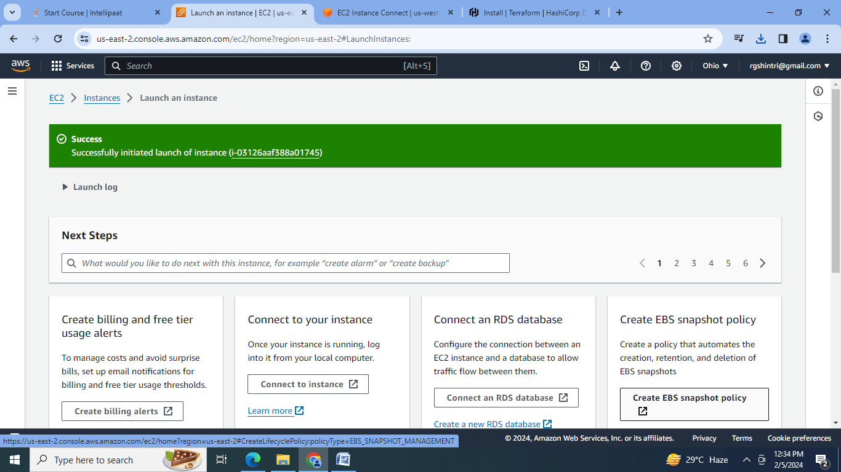

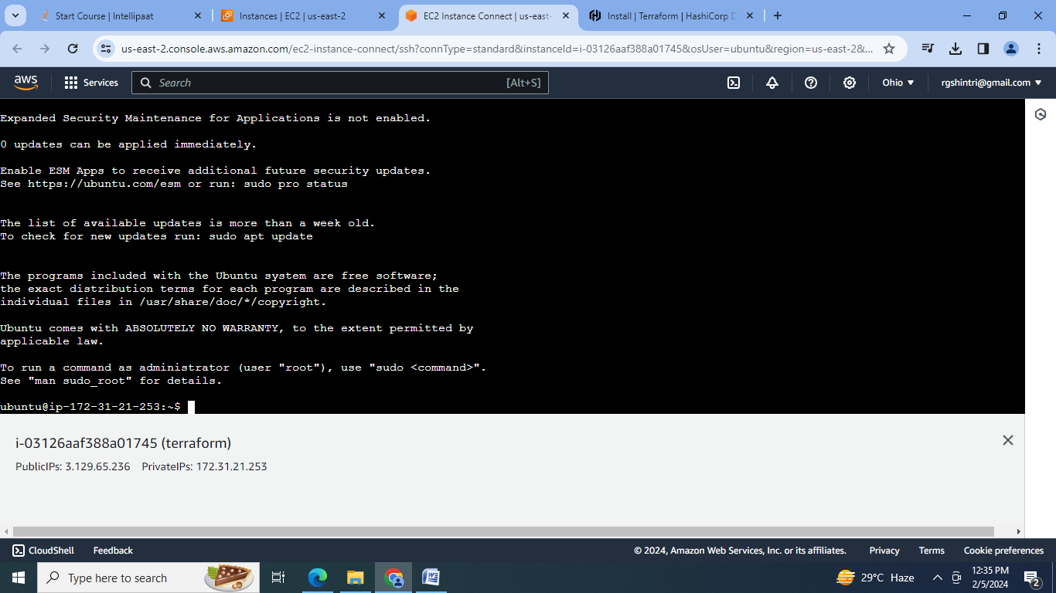

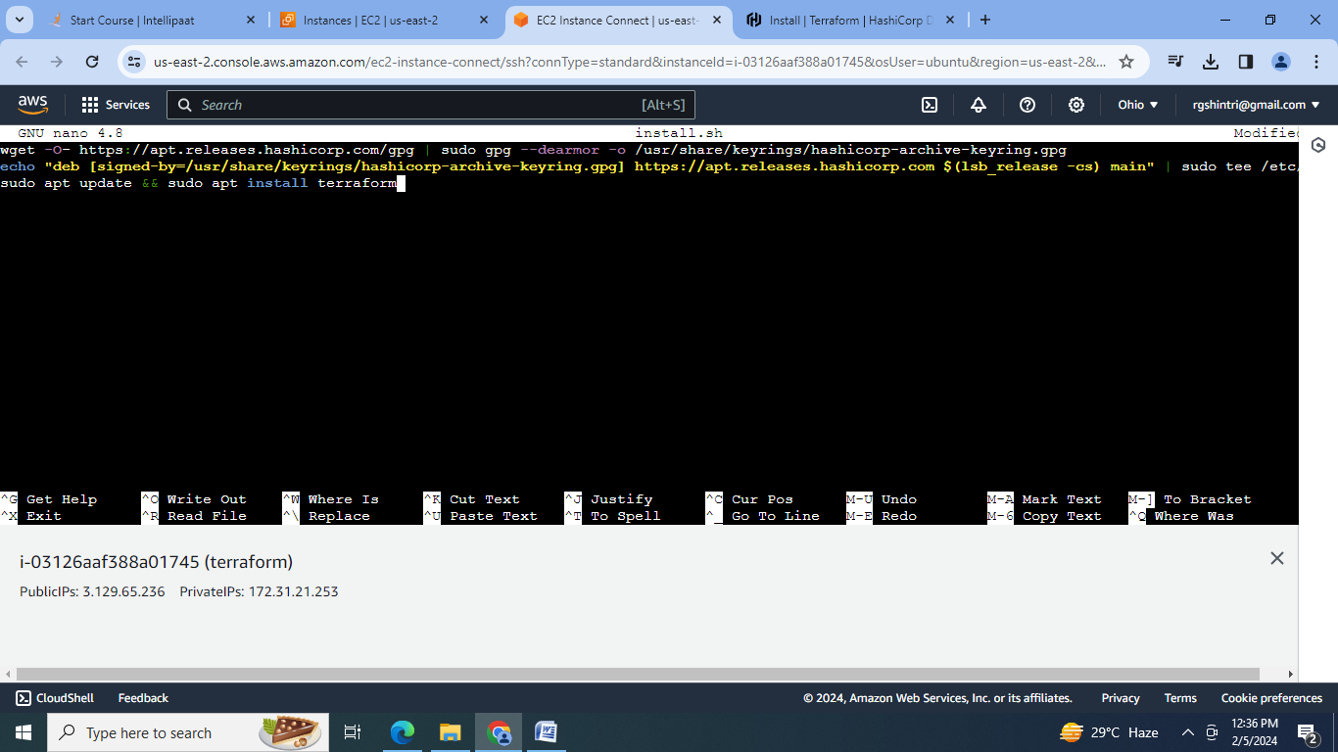

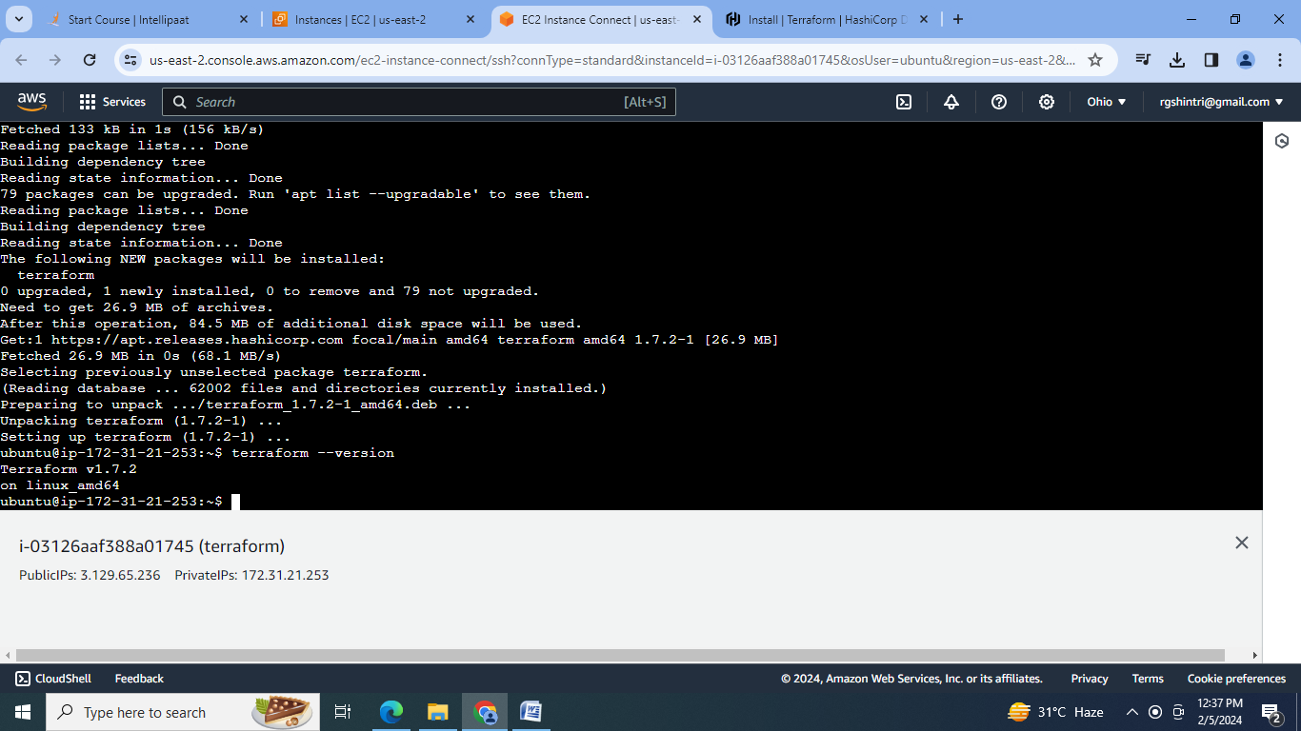

2.Create .tf configuration file:

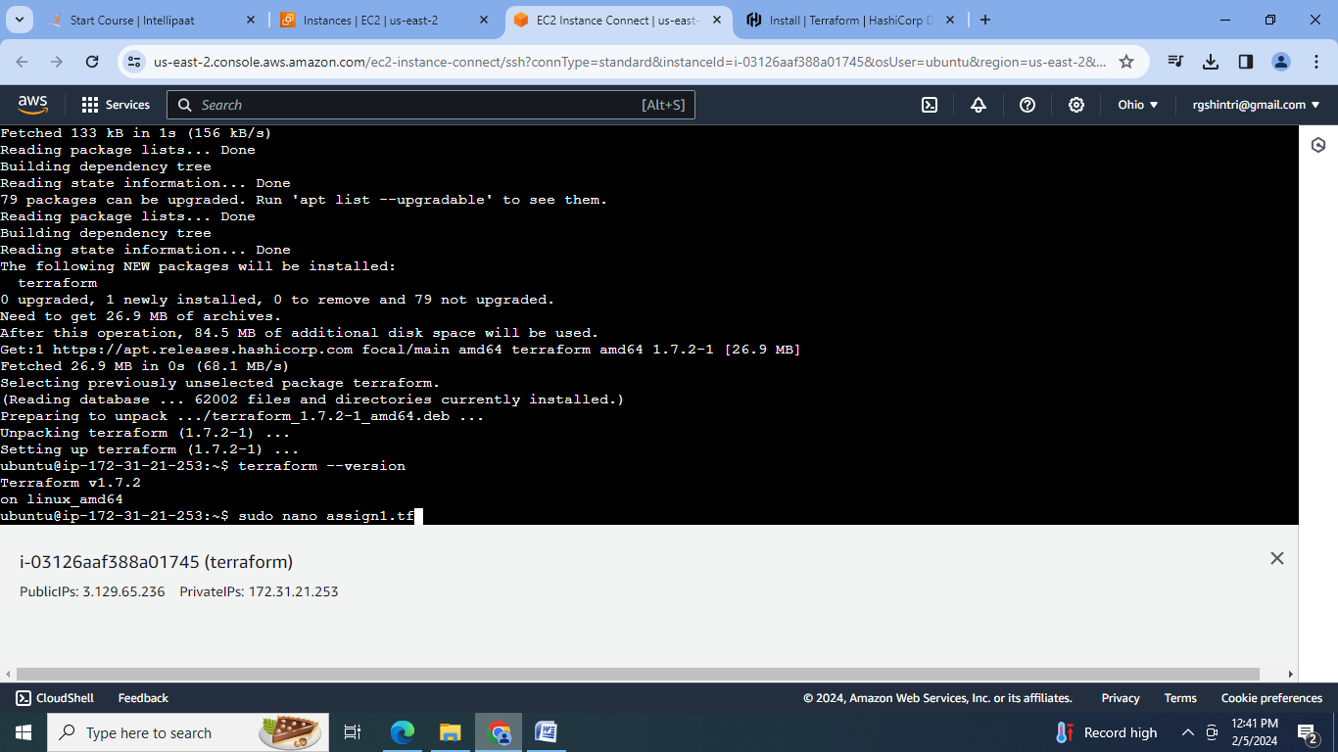

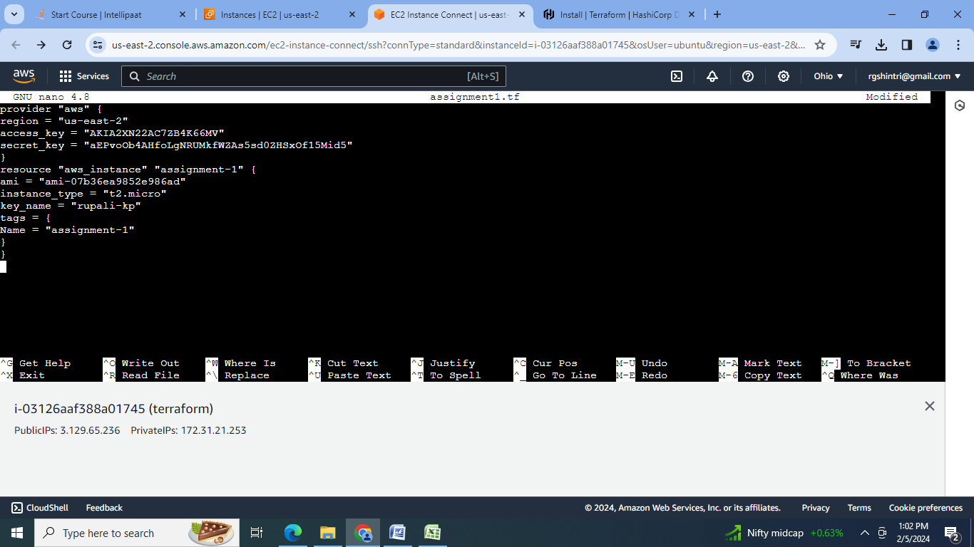

3. Initialize the terraform:

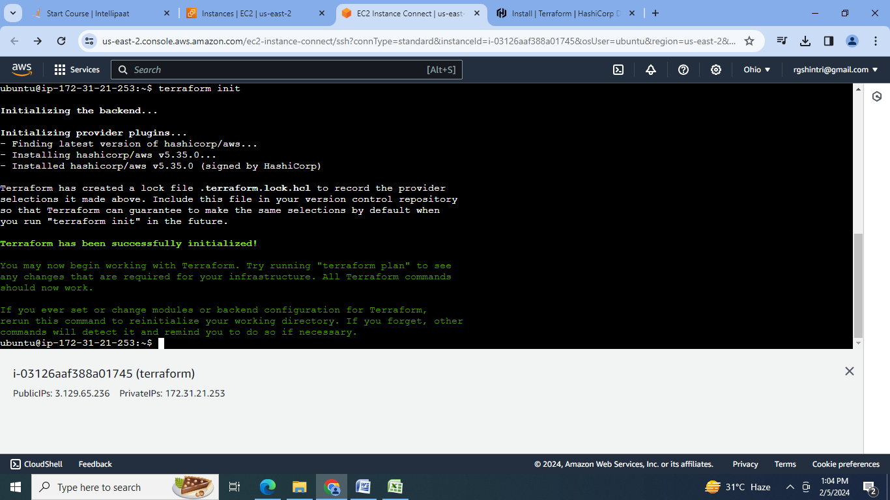

4.Create the configuration Plan :

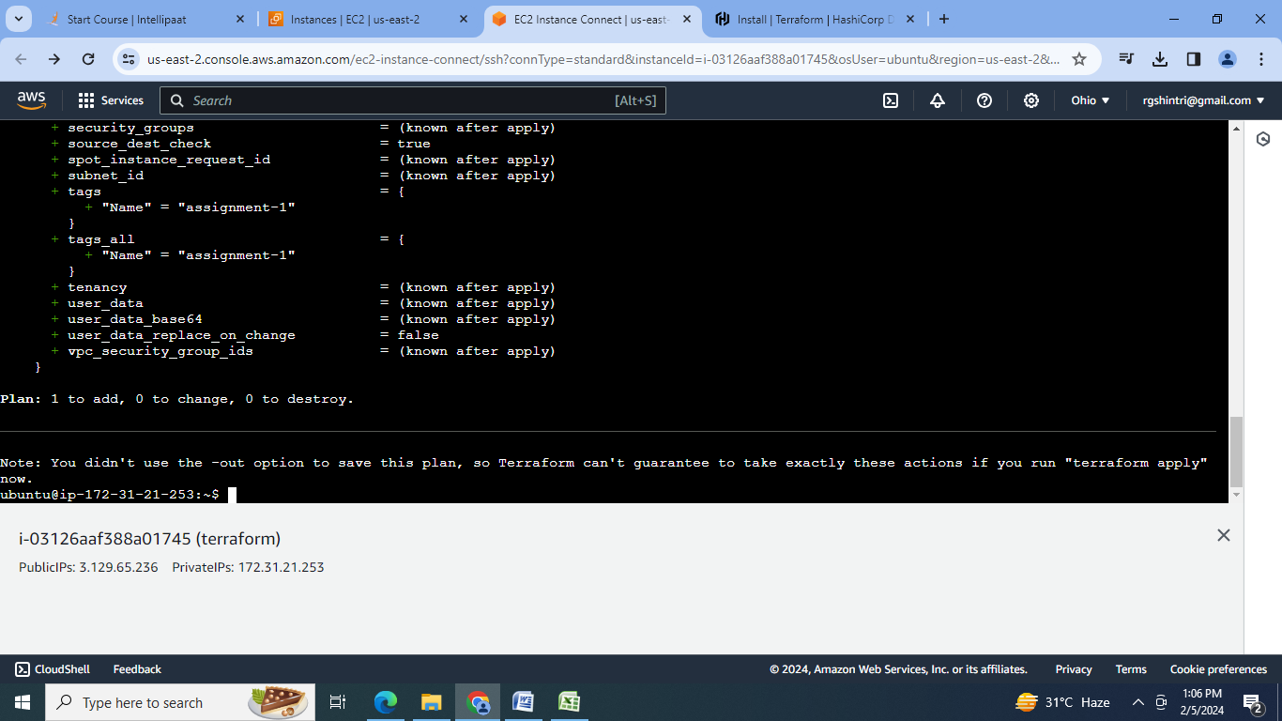

5. Confirm the resource creation by terraform apply:

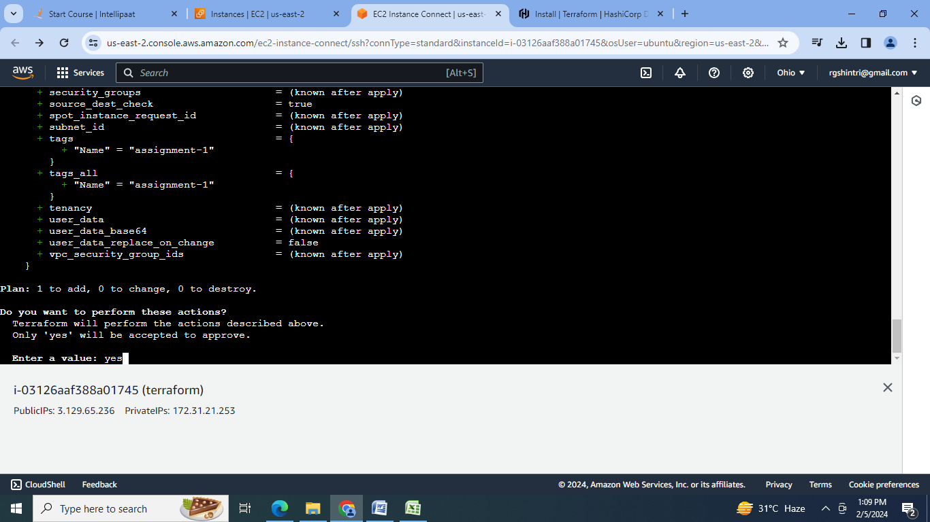

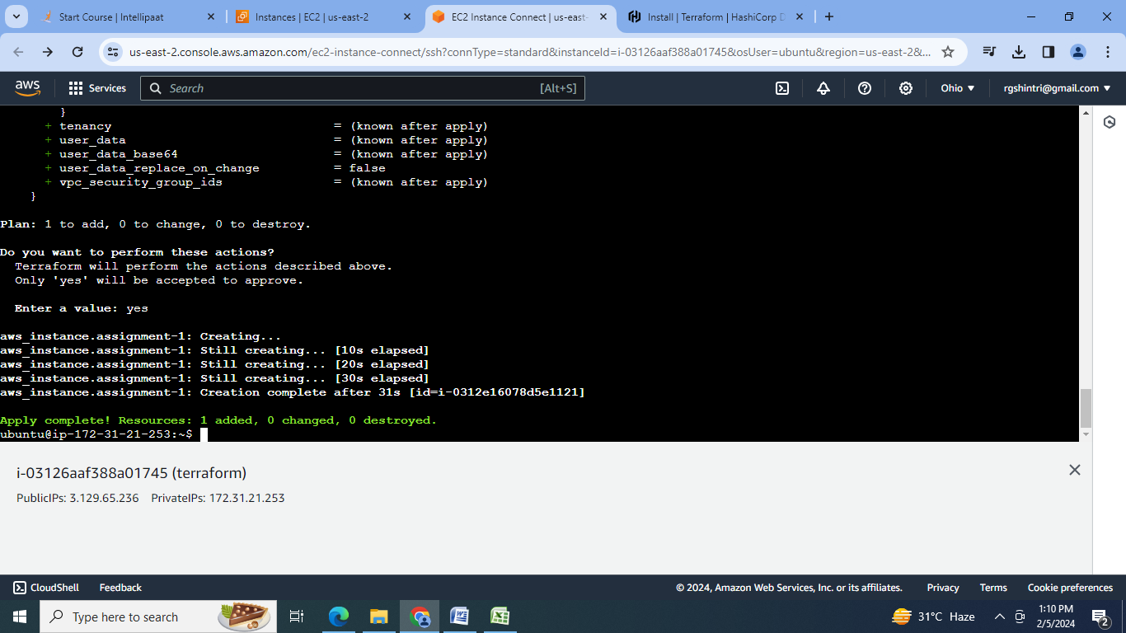

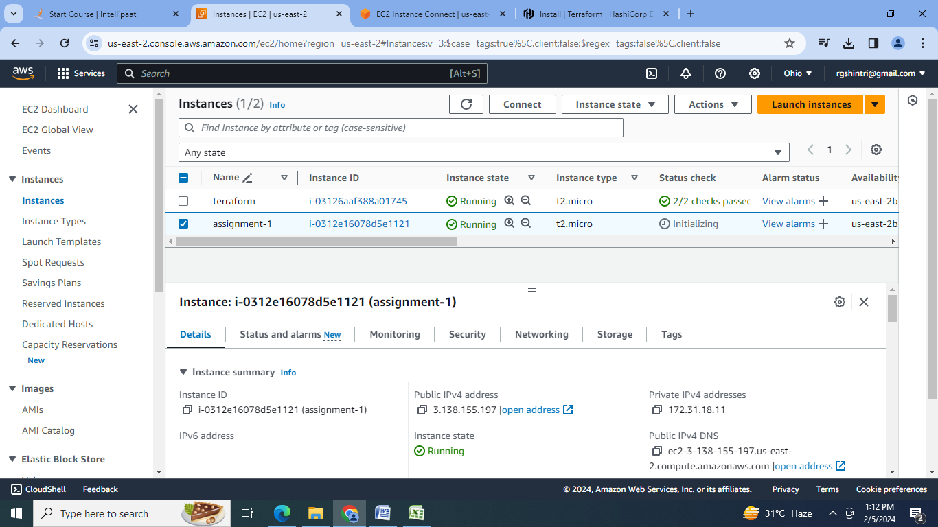

**B] Terraform Assignment 2:**

● Destroy the previous deployment

● Create a new EC2 instance with an Elastic IP

Steps

1. Destroy the previous deployment with terraform destroy:

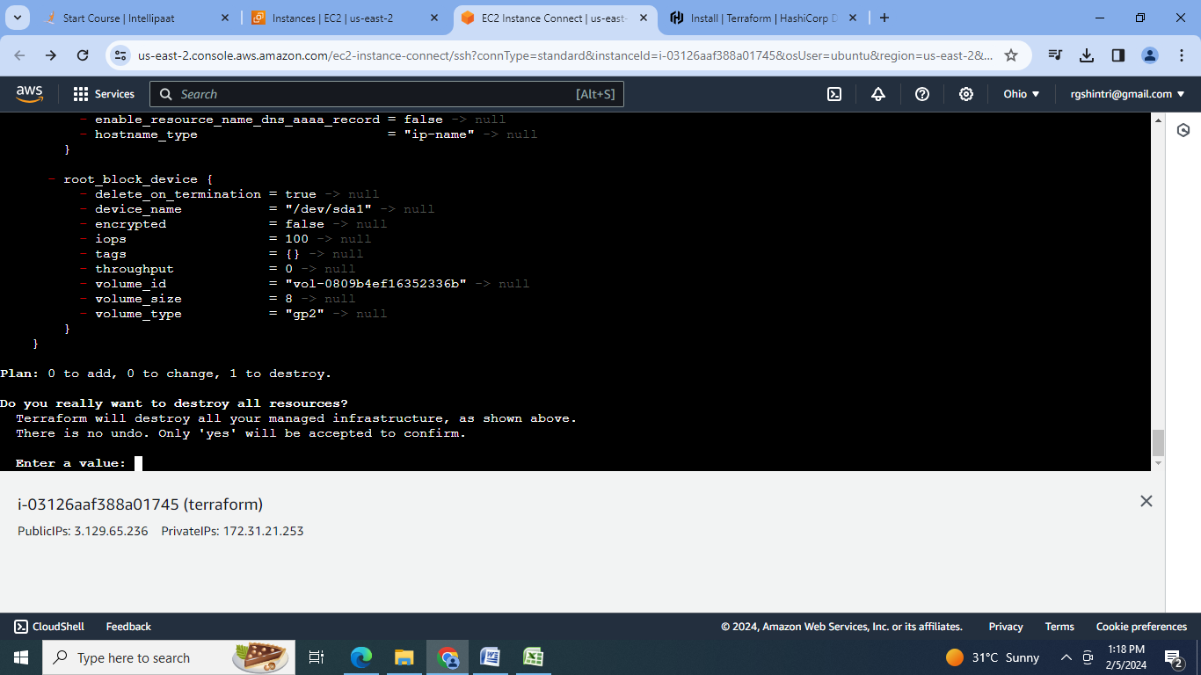

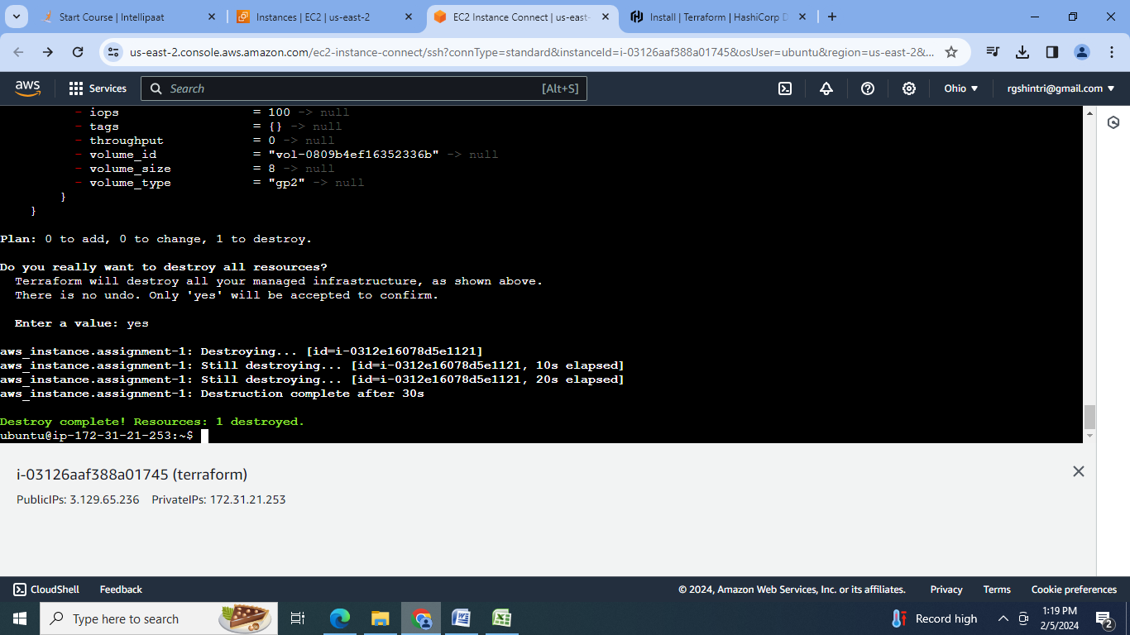

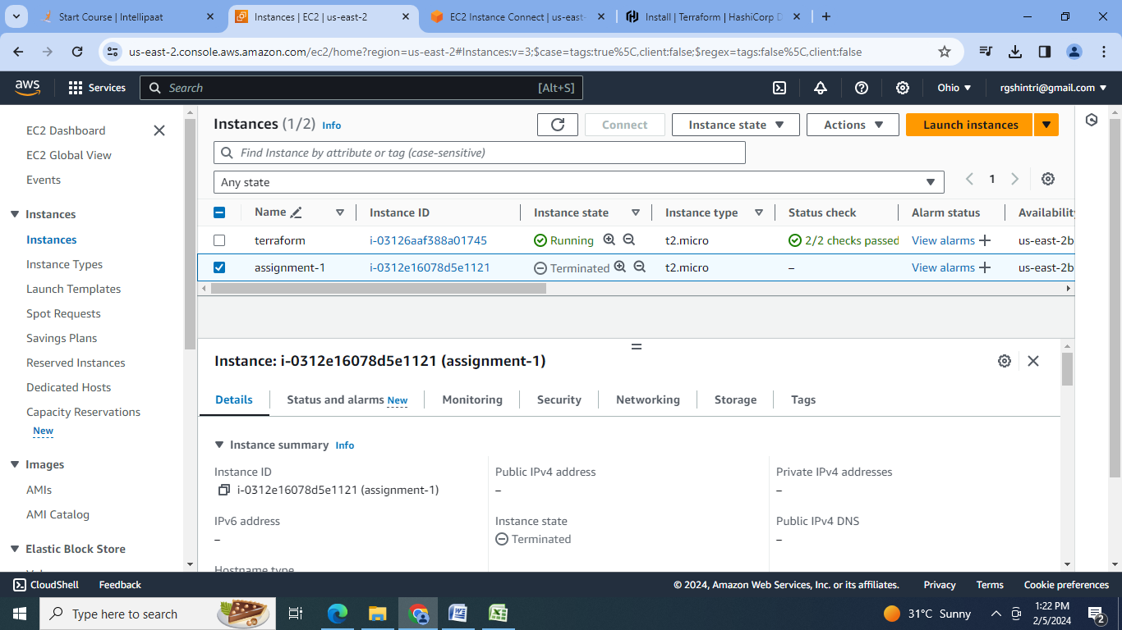

2.Create .tf configuration file for EC2 creation with elastic IP:

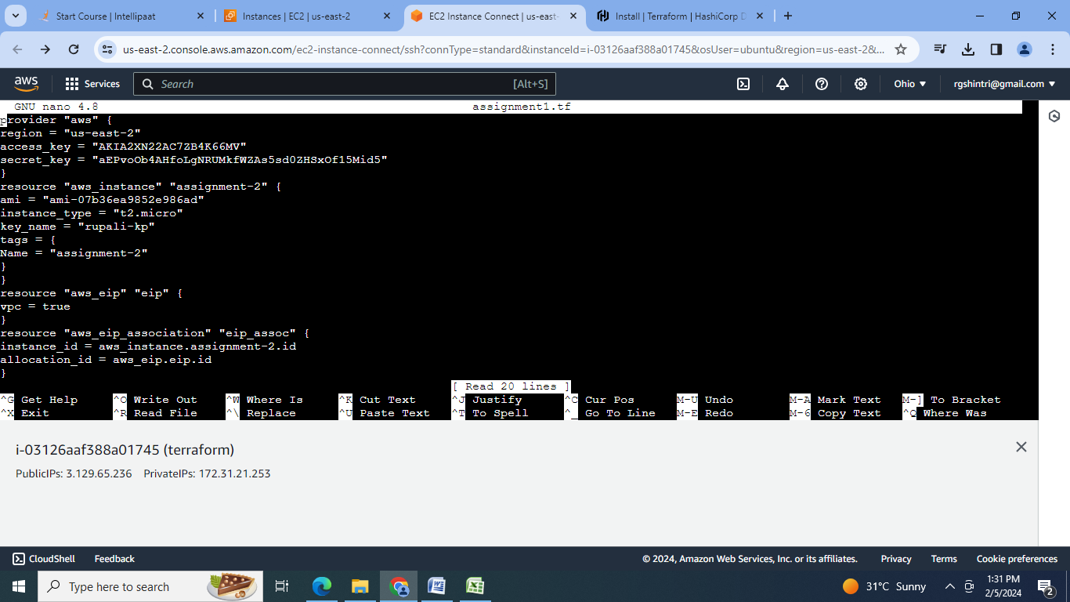

3.Initialise terraform:

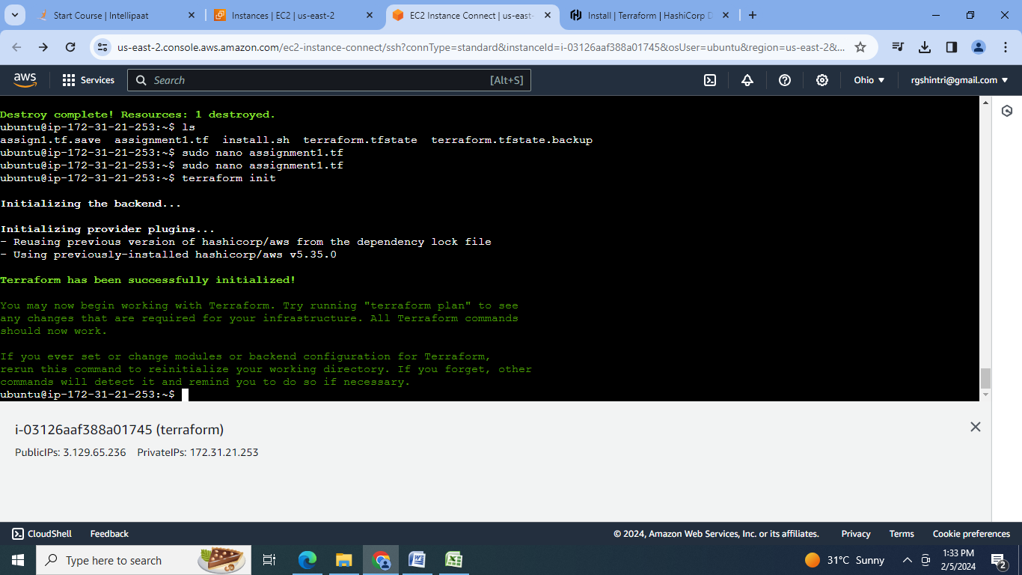

4.Create the configuration Plan :

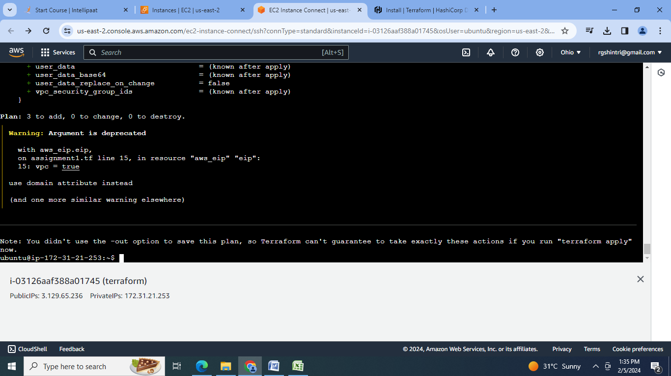

5. Confirm the resource creation by terraform apply:

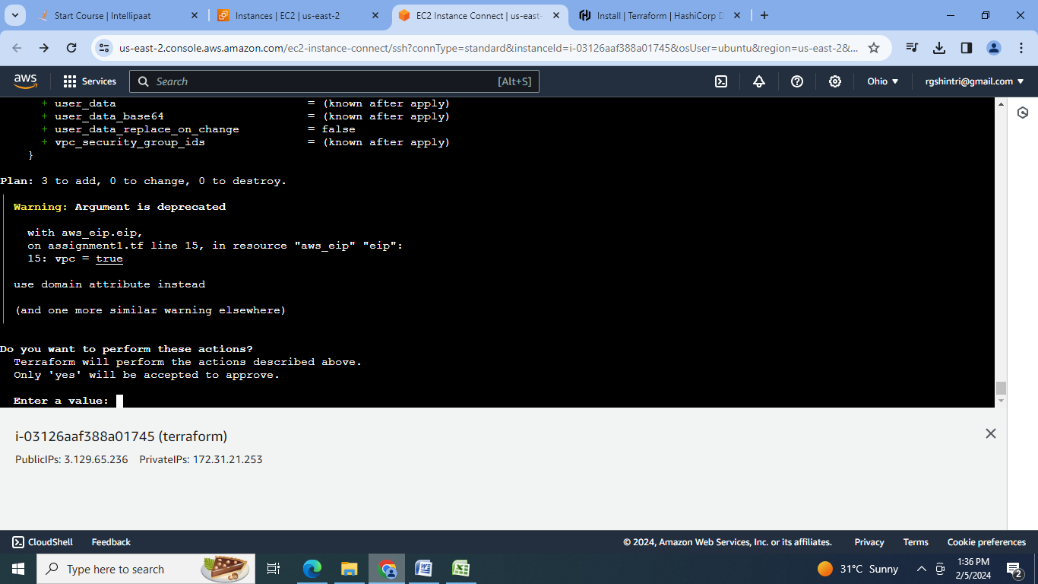

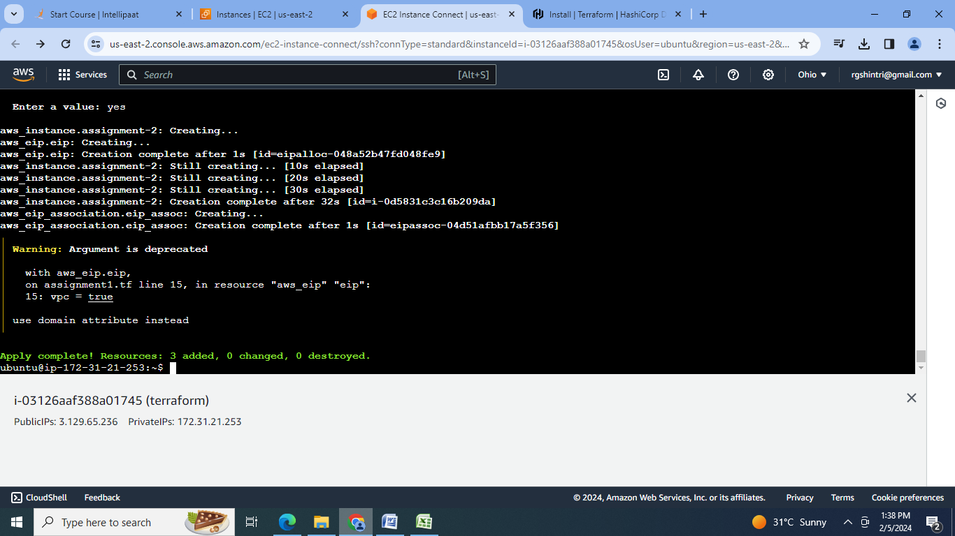

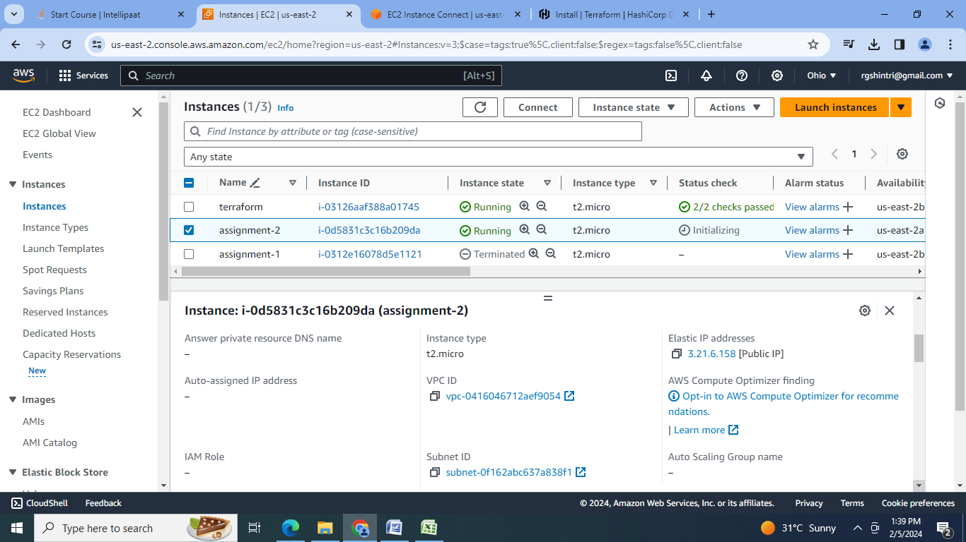

**C] Terraform Assignment 3:**

● Destroy the previous deployment

● Create 2 EC2 instances in Ohio and N.Virginia respectively

● Rename Ohio’s instance to ‘hello-ohio’ and Virginia’s instance to ‘hello-virginia’

Steps:

1.Destroy the previous deployment with terraform destroy:

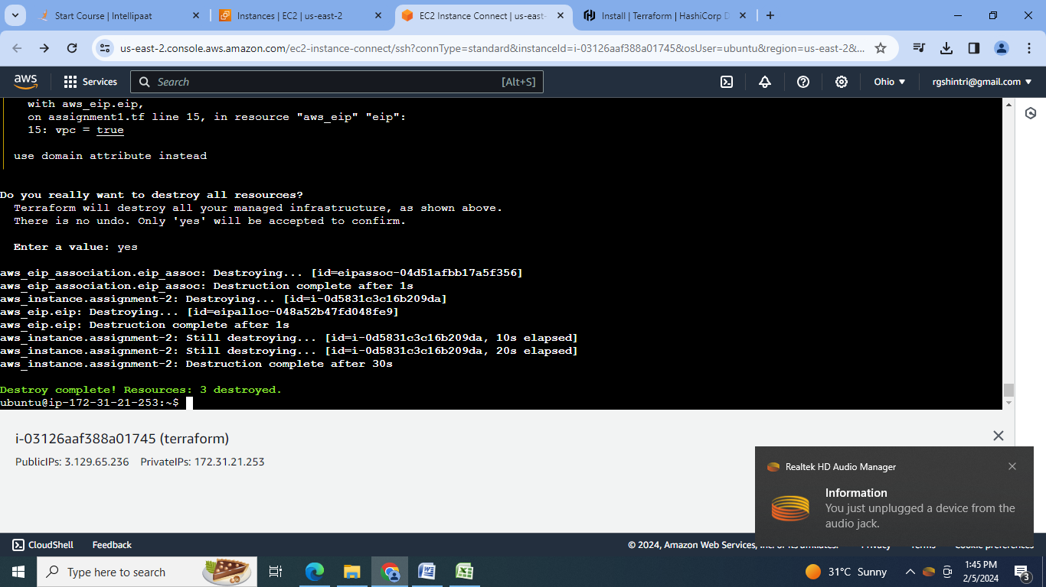

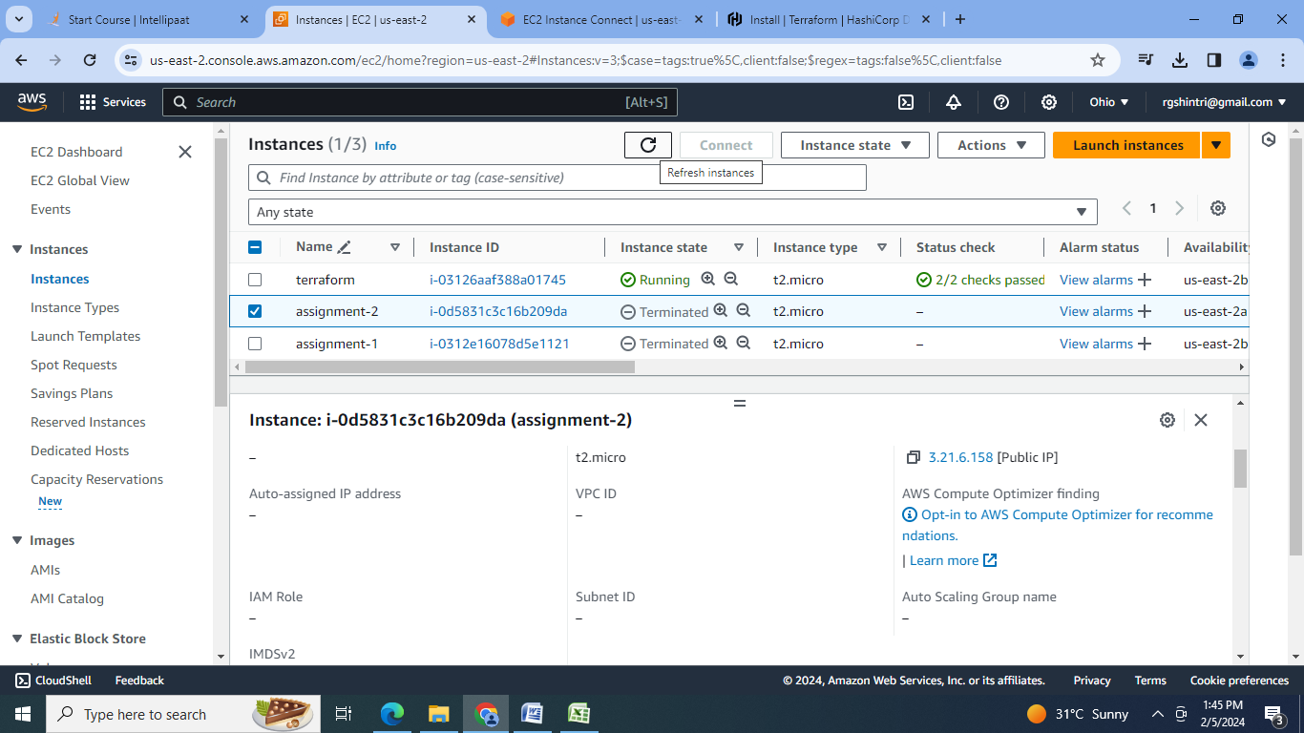

2.Create the configuration file:

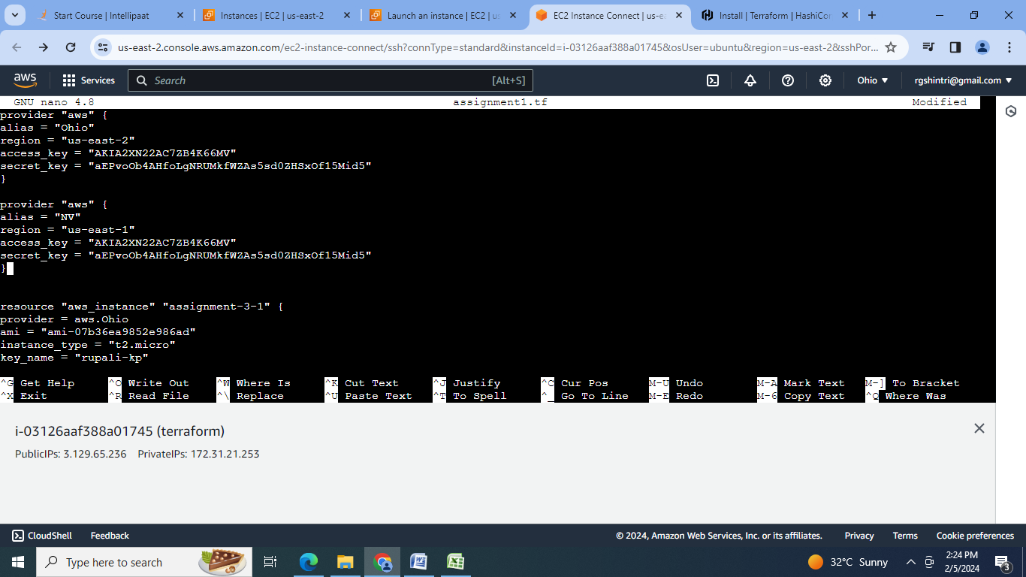

3.Initialise terraform:

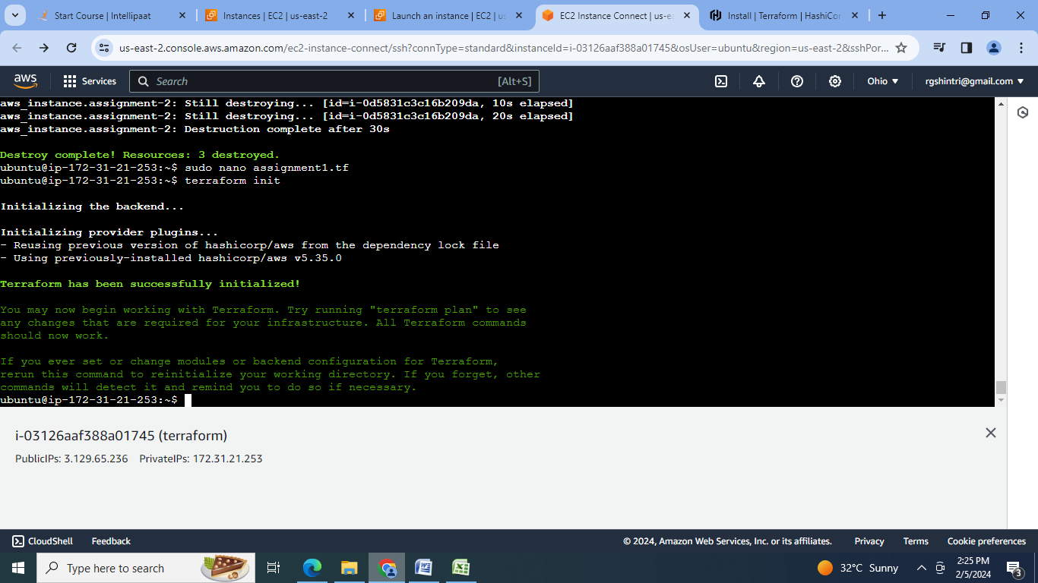

4.Create the configuration Plan :

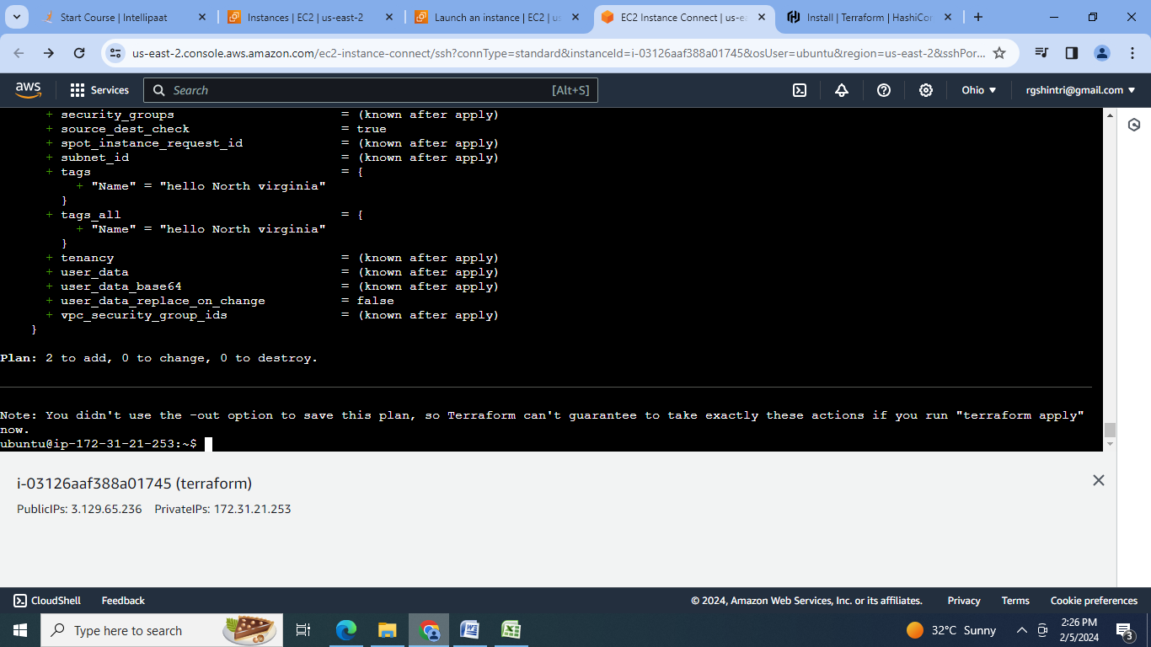

5. Confirm the resource creation by terraform apply:

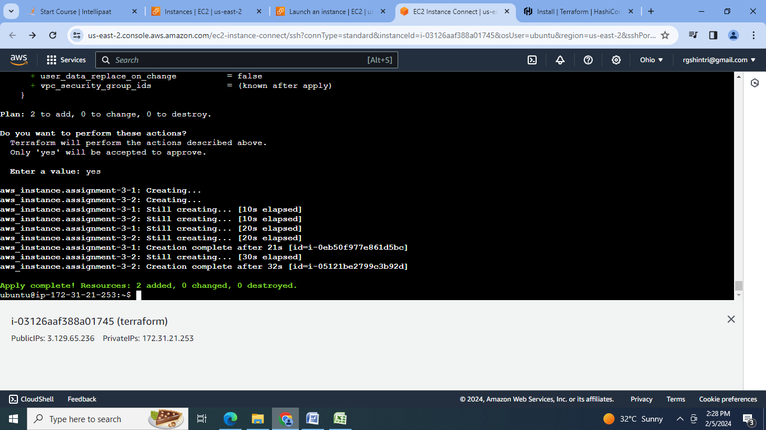

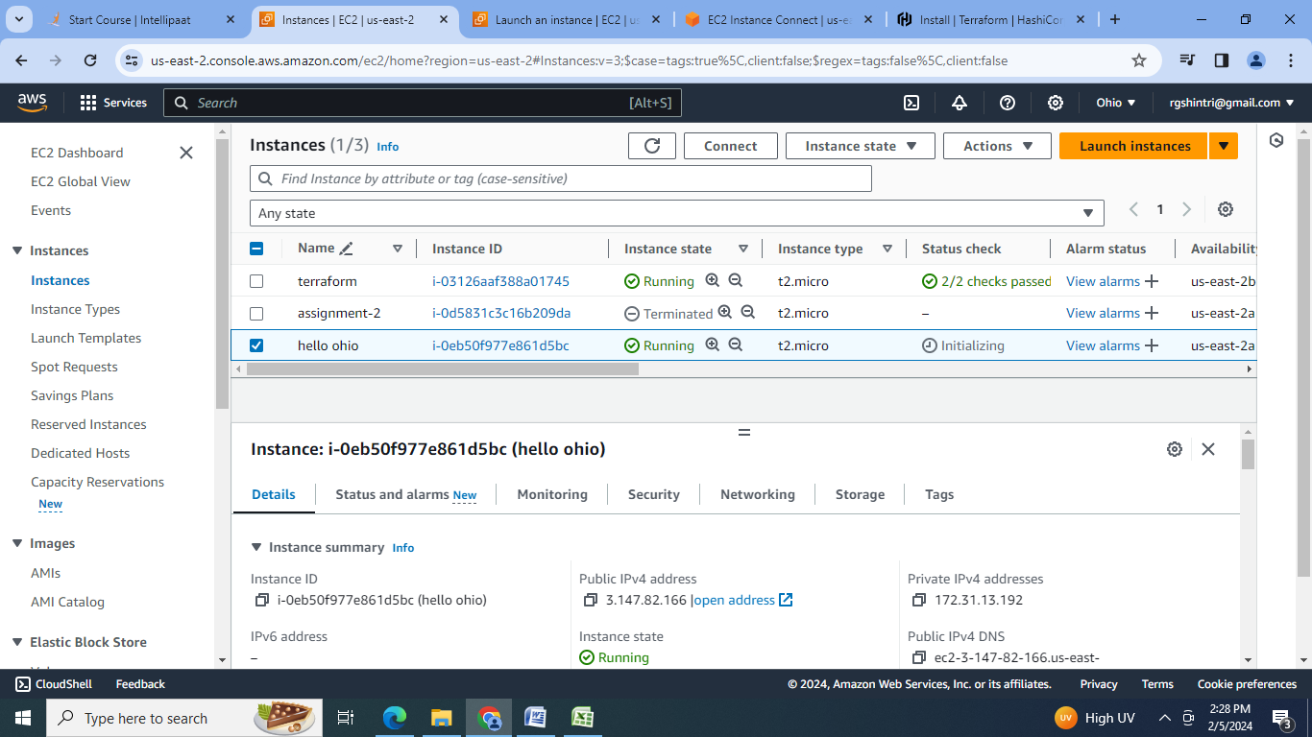

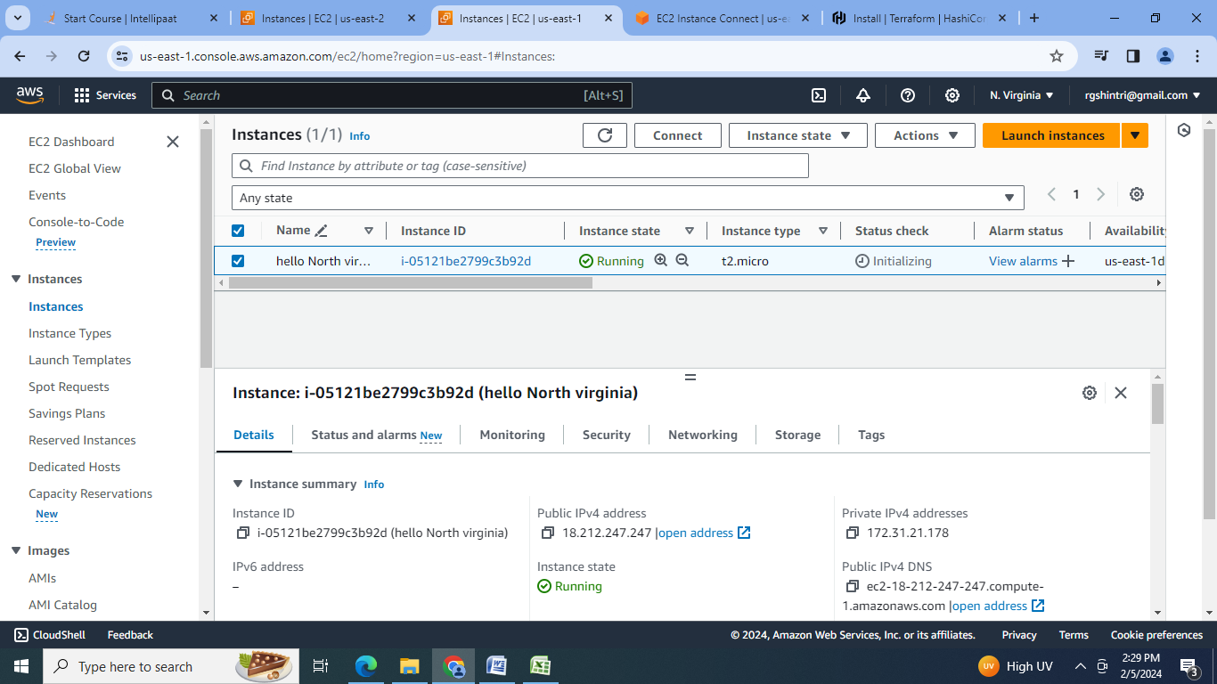

**D] Terraform Assignment 4:**

● Destroy the previous deployments

● Create a VPC with the required components using Terraform

● Deploy an EC2 instance inside the VPC

Steps:

1.Destroy the previous deployment with terraform destroy:

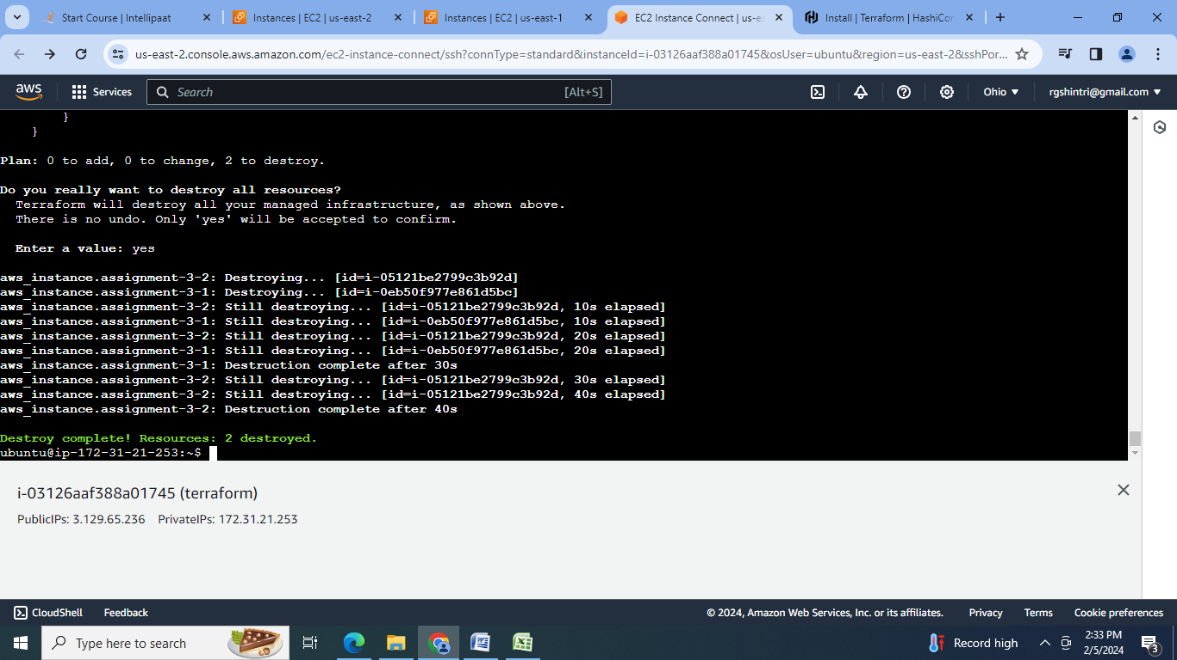

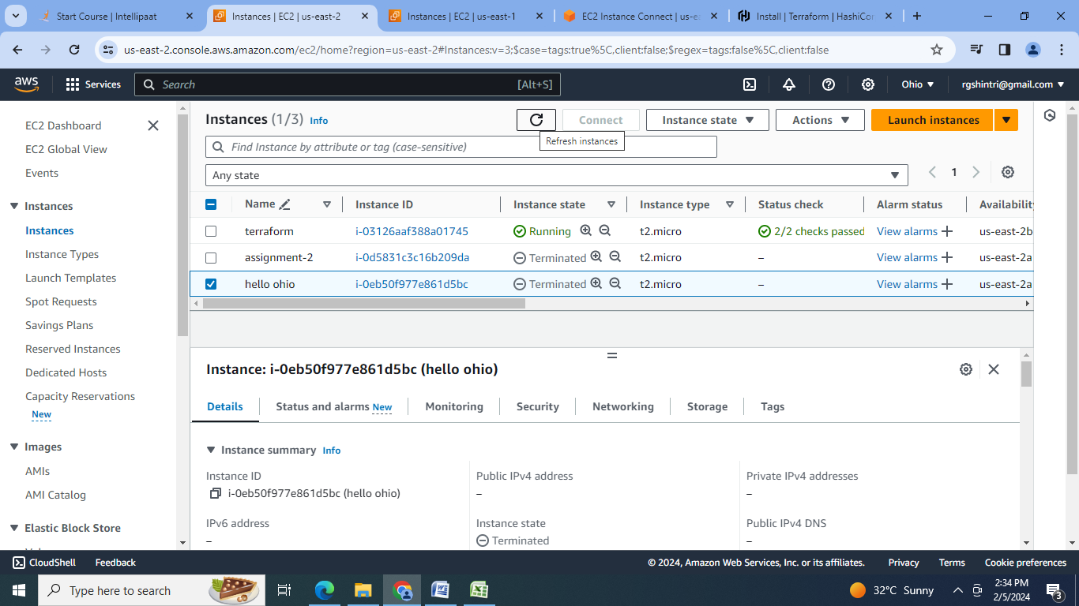

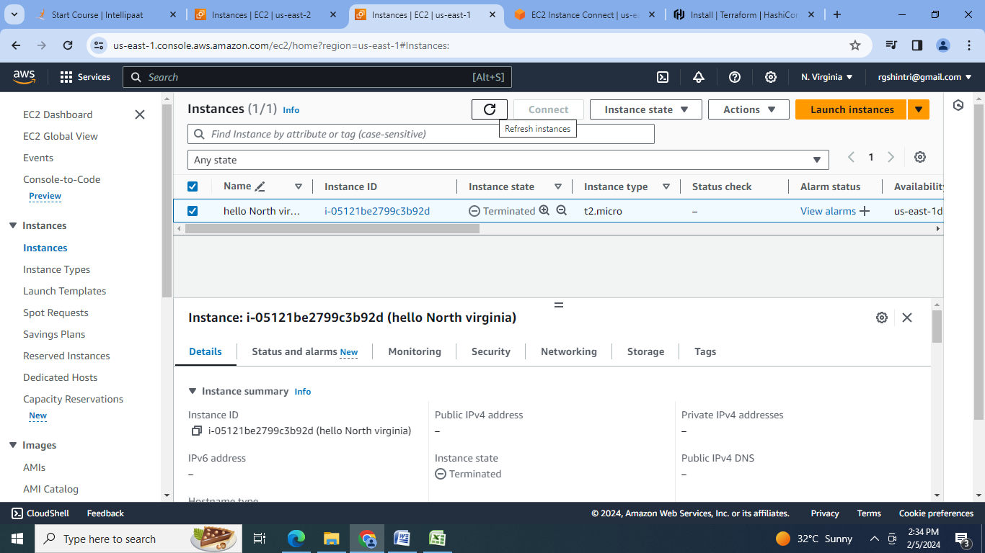

2.Create the configuration file:

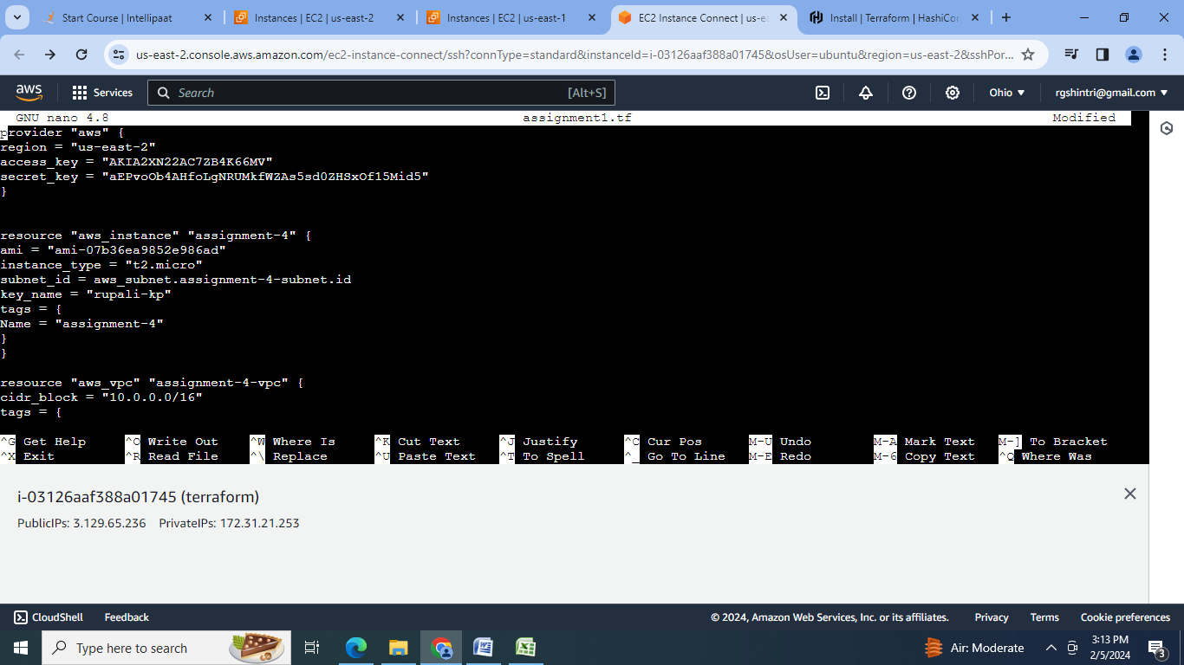

3.Initialise terraform:

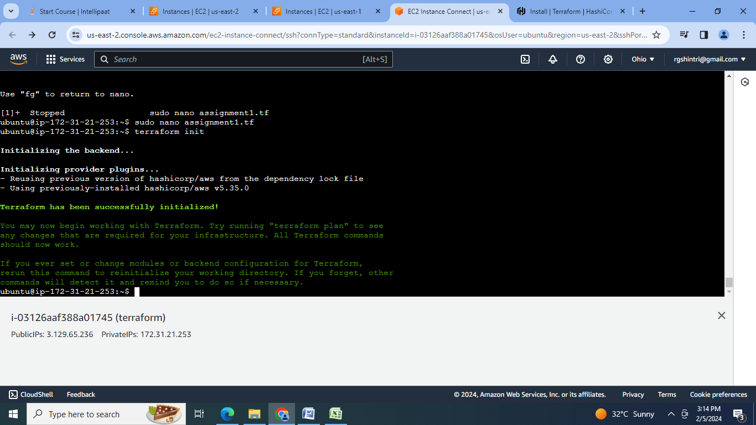

4.Create the configuration Plan :

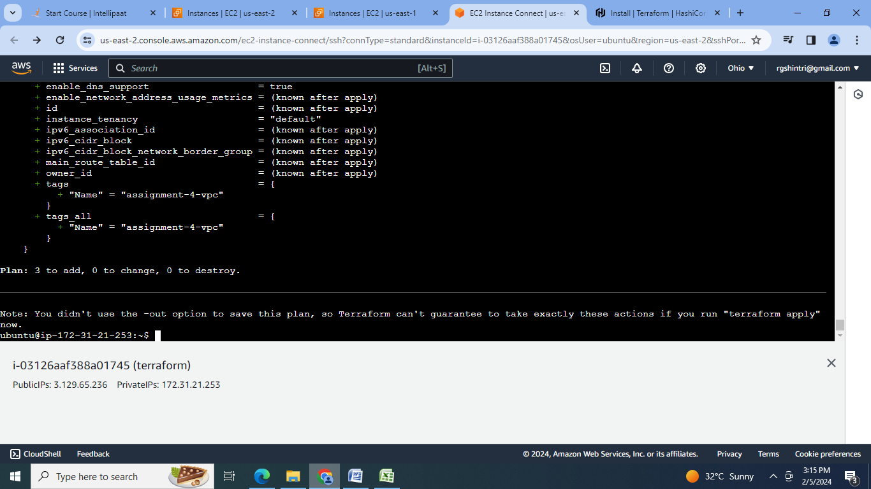

5. Confirm the resource creation by terraform apply:

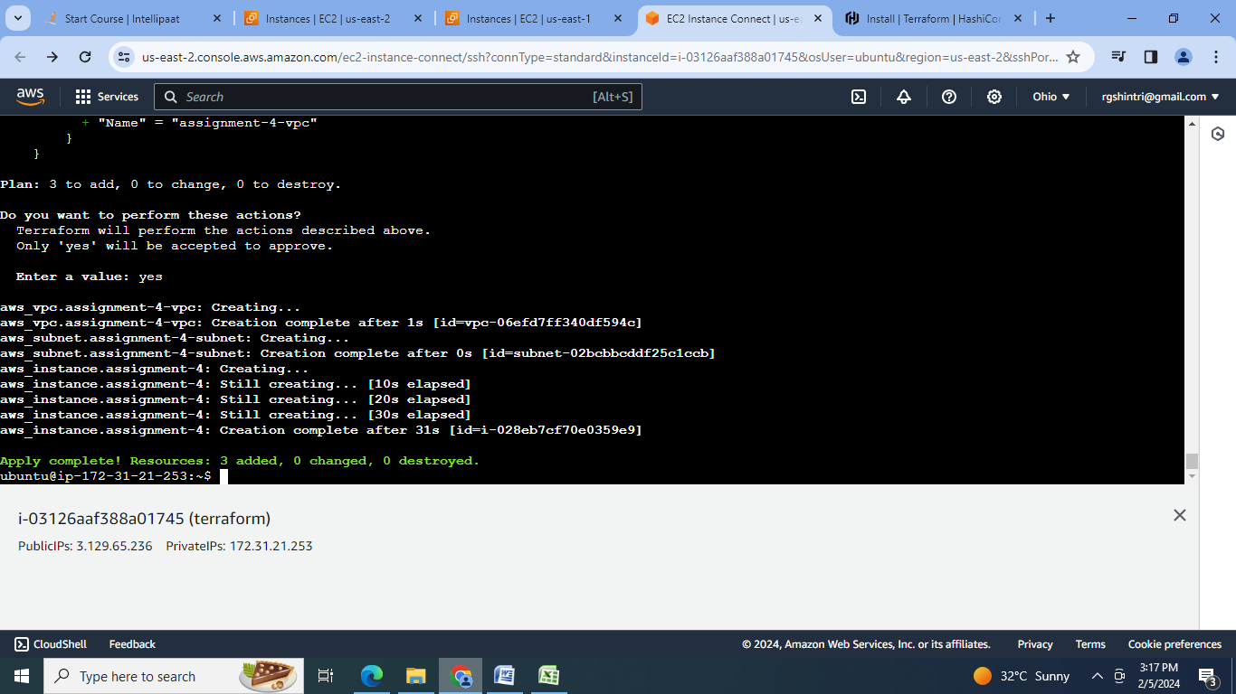

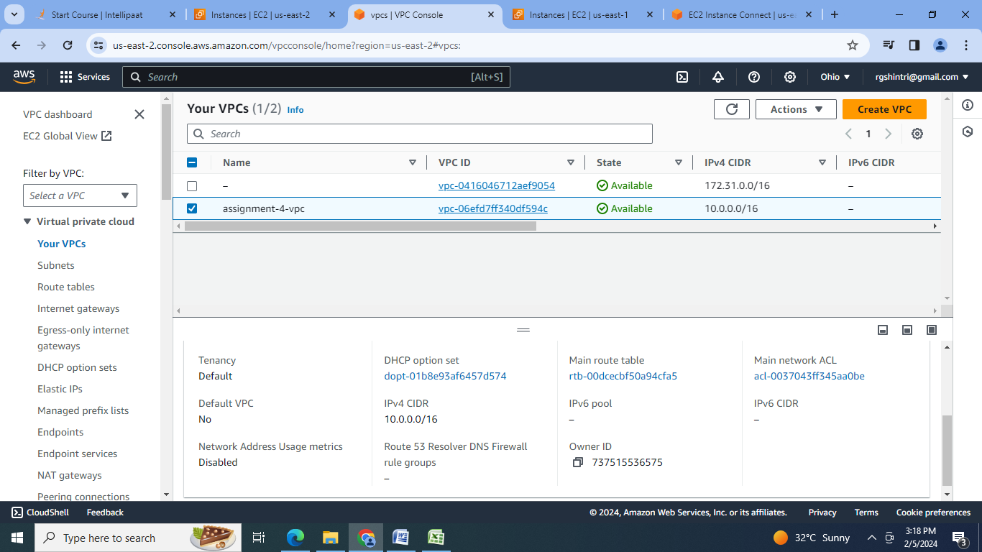

**E] Terraform Assignment 5:**

● Destroy the previous deployments

● Create a script to install apache2

● Run this script on a newly created EC2 instance

● Print the IP address of the instance in a file on the local, once deployed

Steps:

1.Destroy the previous deployment with terraform destroy:

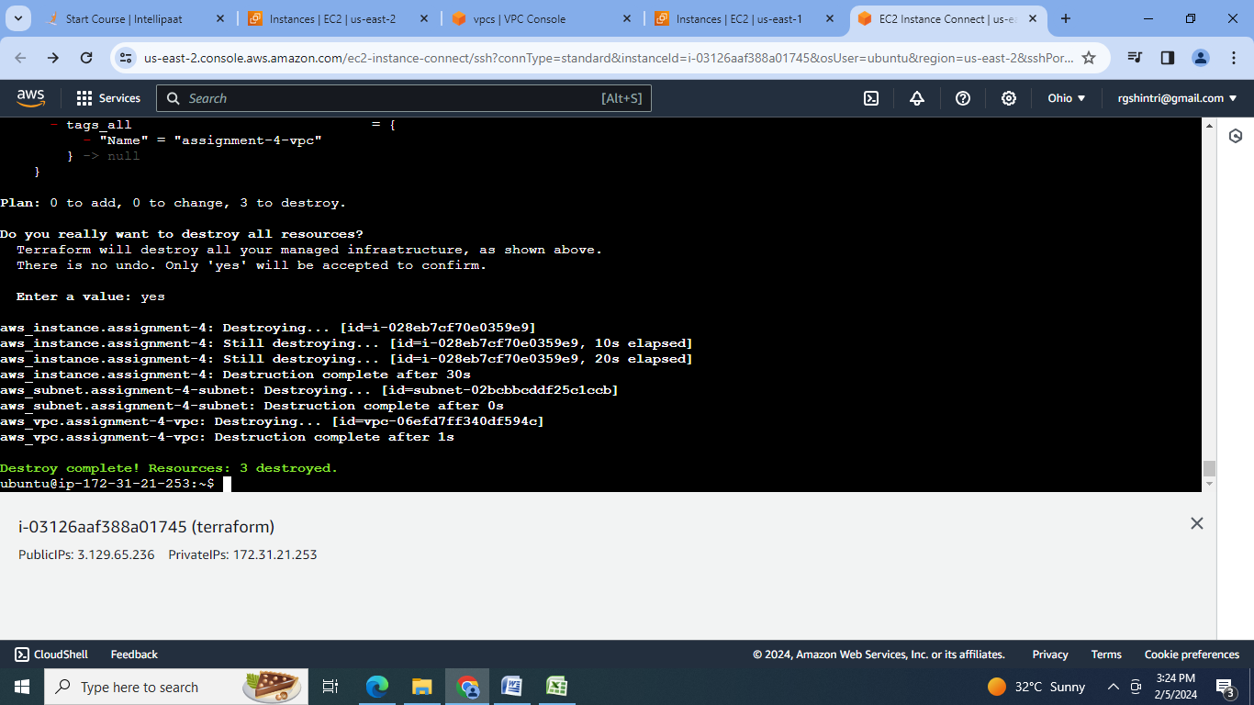

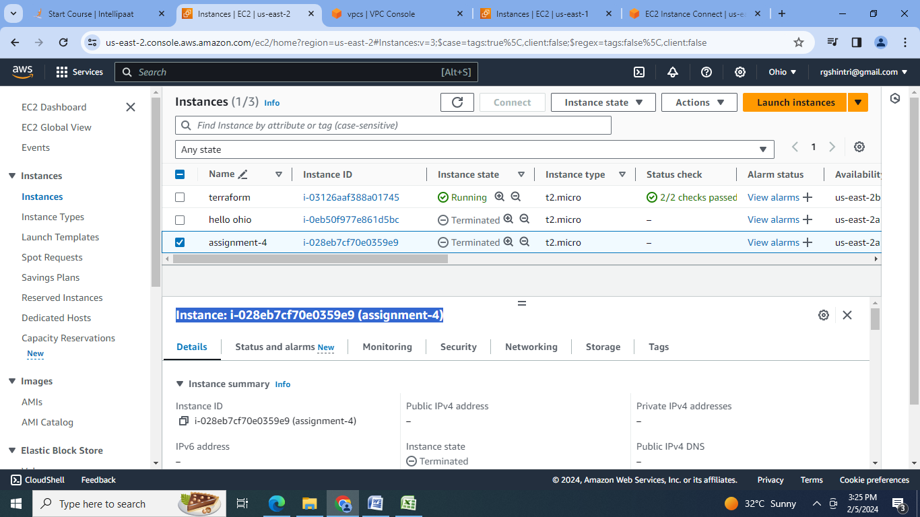

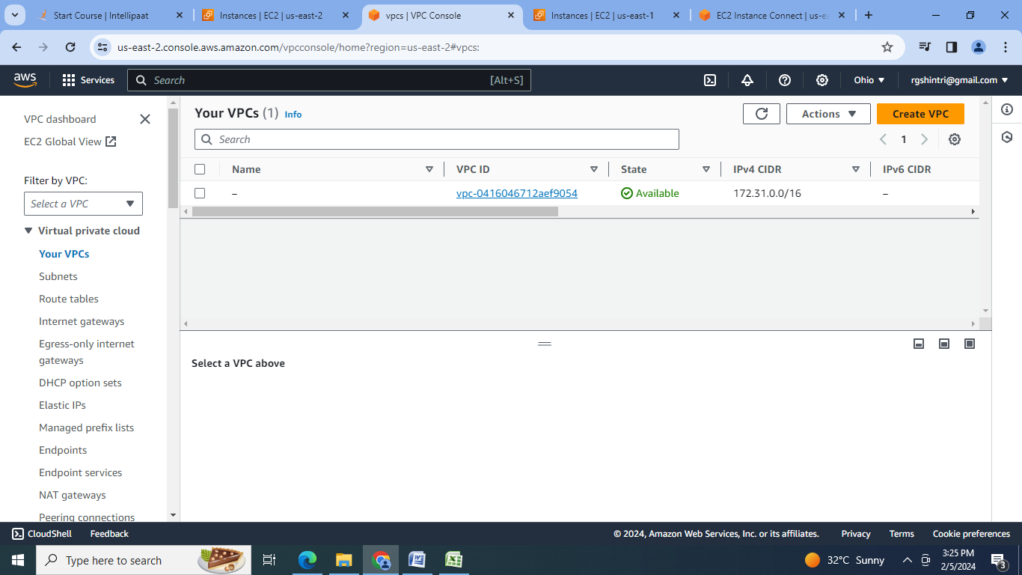

2.Create the configuration file:

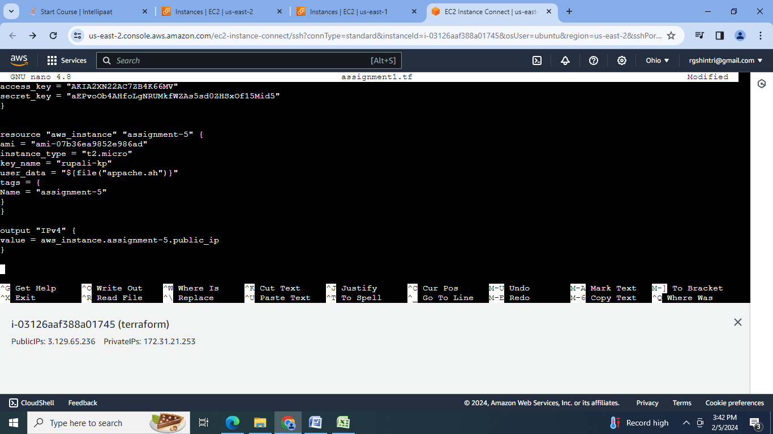

3.Initialise terraform:

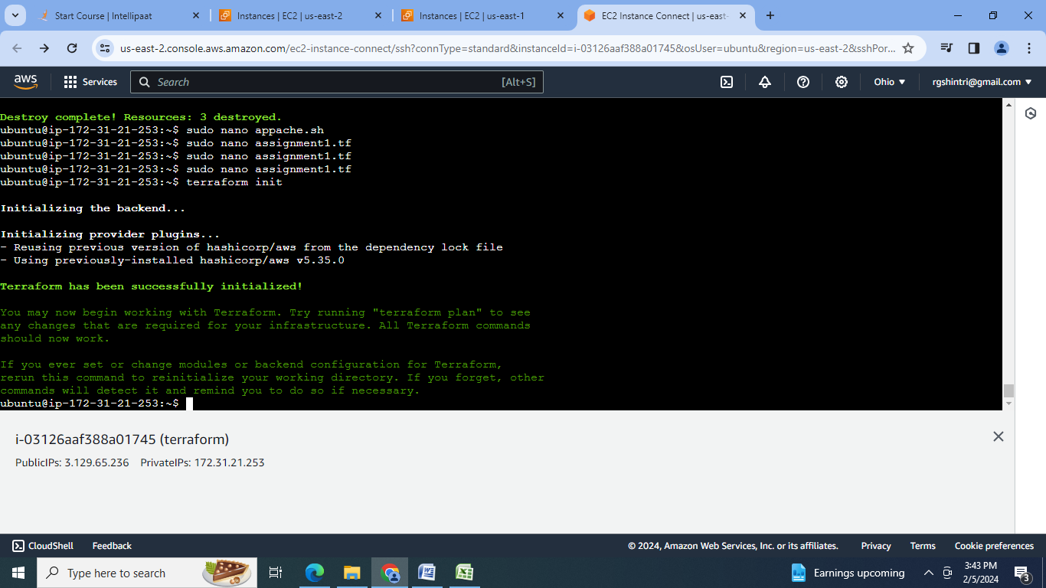

4.Create the configuration Plan :

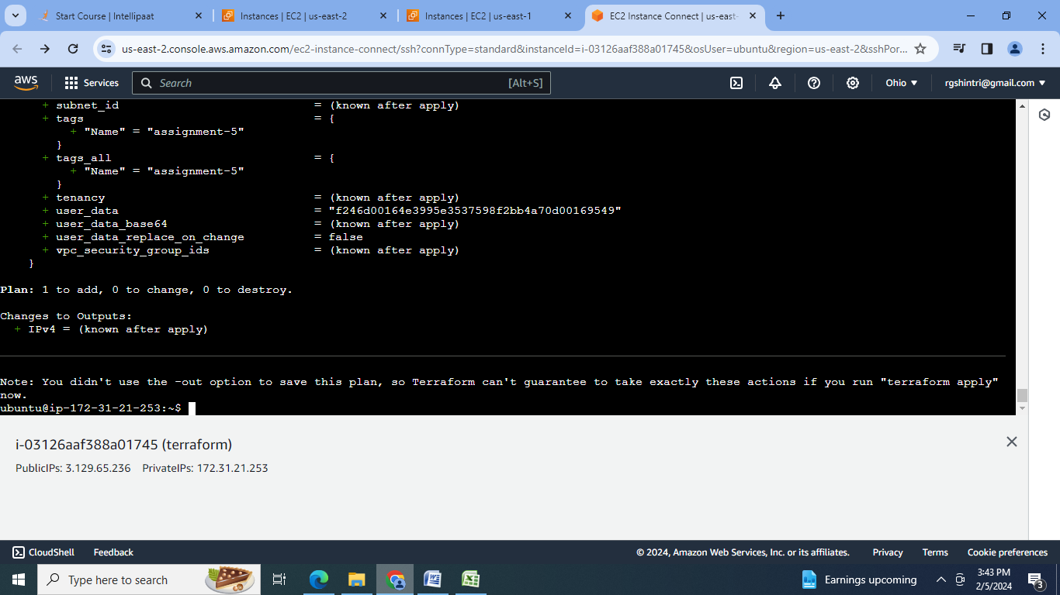

5. Confirm the resource creation by terraform apply:

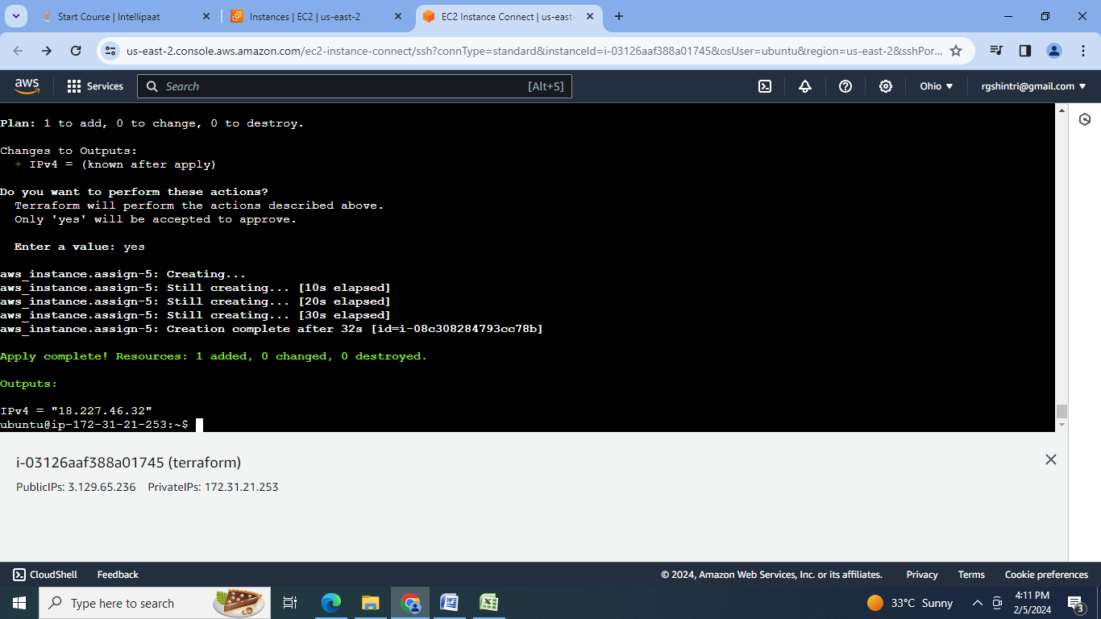

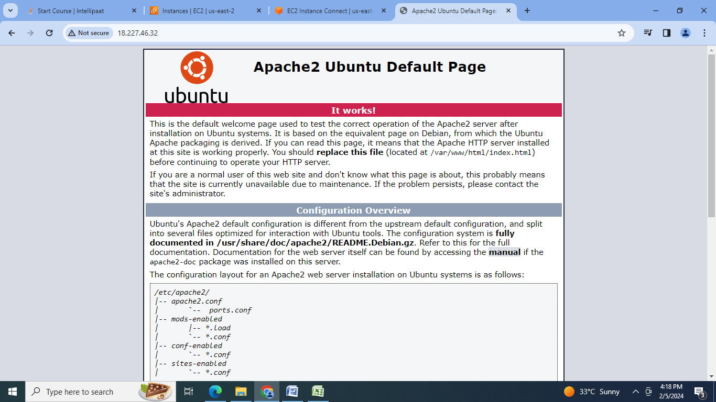

**Conclusion:** So terraform is a open source IaaC tool that allow us to define and the provision of the resources in the declarative configurative scripts like networks, servers etc.

